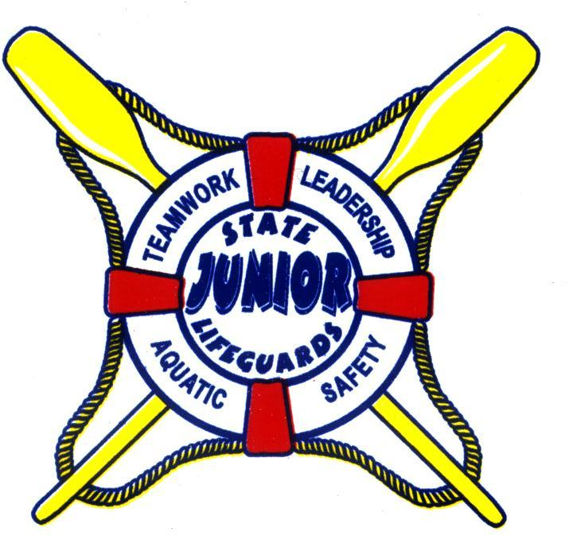

MONTEREY JUNIOR LIFEGUARDS
ASSISTANT APPLICATION
2211 Garden Road, Monterey, CA 93940
Email: montereyjg@parks.ca.gov
Phone: (831) 649-7144

Name: ______________________________ _________________________________________________
 | FIRST | LAST
Address: ________________________________________________________________________________
Number | Street | City | Zip
Sex: Male  Female  Date of Birth: ____/____/_____ Age ________

Phone: ( ) ____________________Email Address: ___________________________________________

SESSION REQUESTED (check)

❒ Session I Monterey State Beach

❒ Session II Monterey State Beach

❒ Both Sessions I & II

Ethnicity (optional): Hispanic , White , Black , Filipino , American Indian , Asian, Other , Decline to State 

EMERGENCY CONTACTS and INFORMATION

Mother's Name: ________________________Phone 1 ( ) _____________ Phone 2 ( ) _____________
Mother's Occupation: ___________________________Business Name: _____________________________
Father’s Name: ________________________ Phone 1 ( ) _____________Phone 2 ( ) _____________
Father's Occupation: ___________________________Business Name: _____________________________
If the contacts above can not be reached in an emergency, please contact:
Name: ___________________________________________ Phone:( )___________________________
Name: ___________________________________________ Phone:( )___________________________
Physician or HMO: __________________________________Phone:( ) __________________________
List any restrictions to medical treatment: ________________________________________________________________________________________
________________________________________________________________________________________
Special Medications, Pertinent Information or Special Instructions:
________________________________________________________________________________________________________________________________________________________________________________________________________________________________________________________________________
Allergies to foods or drugs:
________________________________________________________________________________________
________________________________________________________________________________________
________________________________________________________________________________________

Date of Last Tetanus Diphtheria Booster: _______________________________________________________________________________________

Years participated in the Monterey Junior Lifeguard Program:

_______

VIDEO/PHOTO RELEASE
I give the State of California, Department of Parks and Recreation (DPR) permission to make photographs, videotapes, films or other likenesses of me, my child or legal ward. I hereby grant to DPR the unrestricted right to copyright any of the above-mentioned materials containing images of me, as well as the unrestricted right to use and reuse them, with their caption information, in whole or in part, in any manner, for any purpose and in any medium now known or hereinafter invented. These rights include, but are not limited to, the right to publish, copy, distribute, alter, license and publicly display these materials and images for editorial, trade, marketing and/or advertising purposes. I also grant to DPR and its licensees the unrestricted right to use and disclose my name in connection with use of the above materials.
I understand and agree that I will not be paid for any use described above.
I also waive, and release and discharge the State of California, DPR, its officers, employees and/or agents from, any and all claims arising out of or in connection with any use of the materials, caption information and images described above, including any and all claims for libel, defamation and/or invasion of privacy or publicity. I realize I cannot withdraw my consent after I sign this form and I realize this form is binding on me and my heirs, legal representatives and assigns.

_____________________________________________________________________________________
Signature of Parent or Legal Guardian Date

RELEASE OF LIABILITY
I understand that my child or the minor for whom I act as a lawful court-appointed guardian whose name is ___________________________ (“Minor” or “Child”) is being considered to participate in the Junior Lifeguard Program (“Program”) administered by the California Department of Parks and Recreation (“DPR”).
I acknowledge that by signing this RELEASE OF LIABILITY, I will be giving up certain legal rights on behalf of myself and the Minor.
Hereinafter, the terms “undersigned,” “I” or “my” when used in this RELEASE OF LIABILITY are meant to refer to me as the parent and/or legal guardian on behalf of myself and the Minor.
In consideration of being permitted to participate in the Program, the undersigned agrees to the following.
- THE UNDERSIGNED HEREBY RELEASES, WAIVES, DISCHARGES AND COVENANTS NOT TO SUE THE CALIFORNIA DEPARTMENT OF PARKS AND RECREATION, ITS EMPLOYEES, OFFICERS AND AGENTS (hereinafter referred to as “Releasees”) from all liability to the undersigned, his or her personal representatives, assigns, heirs and next of kin for any loss, damage, or claim therefore on account of injury to the person or property of the undersigned, whether caused by any negligent act or omission of the Releasees or otherwise while the undersigned is participating in the Program or using any of DPR’S facilities in connection with the Program.
- THE UNDERSIGNED HEREBY AGREES TO INDEMNIFY AND HOLD HARMLESS the Releasees from all liability, claims, demands, causes of action, charges, expenses, and attorneys fees resulting from involvement in this activity whether caused by any negligent act or omission of the Releasees.
- THE UNDERSIGNED HEREBY ASSUMES FULL RESPONSIBILITY FOR AND RISK OF BODILY INJURY, DEATH OR PROPERTY DAMAGE while upon DPR property or participating in the activity or using any DPR facilities and equipment whether caused by any negligent act or omission of Releasees. The undersigned expressly agrees that this release and waiver, indemnity agreement and assumption of risk are intended to be as broad and inclusive as permitted by California law.
- THE UNDERSIGNED REPRESENTS that he or she as well as the Minor are familiar with the varied health risks associated with participating in the Program. The undersigned further understands that serious accidents or death can occur during aquatic and marine activities; and that participants in aquatic and marine activities occasionally sustain mortal or serious personal injuries and/or property damage as a consequence thereof. Knowing the risk of aquatic and marine activities, including but not limited to swimming, surfing, lifesaving, windsurfing, body boarding, competition, the undersigned hereby agrees to assume on his or her behalf and on behalf of the Minor those risks, including risks caused by Releasees negligent acts or omissions.
- I, the UNDERSIGNED, acknowledge that I have read the foregoing and that I am aware of the legal consequences of this agreement, including that it prevents me or my Child/the Minor from suing DPR or its employees, agents or officers if I or my Child is injured or damaged for any reason as a result of participation in this activity.
- IF THE PARTICIPANT IS A MINOR, his or her custodial parent must read and execute this agreement. I hereby warrant that I am the legal guardian or custodial parent of the above-named minor child, and agree, on my own and said Minor’s behalf, to the terms and conditions of the foregoing agreement.
- By signing this RELEASE OF LIABILITY, I represent that I have read, understood and voluntarily agreed to abide by its terms and conditions.

________________________________________________________________________________________
Signature of Parent or Legal Guardian Date

AUTHORIZATION TO TREAT MINOR
I, _________________________, am the [parent or parent having legal custody or guardian or caregiver and a relative] of __________________, a minor (“Minor”). Under Family Code Section 6550, I may authorize medical and dental care for the aforementioned child.
I hereby authorize and consent to any x-ray examination, anesthetic, medical or surgical diagnosis or treatment and hospital care to be rendered to him or her under the general or special supervision of and upon the advice of a physician and/or surgeon licensed under the provisions of the Medical Practice Act or a dentist licensed under the provisions of the Dental Practice Act.
I understand that this authorization is given in advance of any specific diagnosis, treatment or hospital care being required, but it is given to provide authority and power to render care which the aforementioned physician, surgeon or dentist in the exercise of his or her judgment, may deem advisable for the Minor.
Further, I understand the Minor will be participating in a hazardous recreational activity that may result in injury.
I agree to pay for the Minor’s medical expenses, including the cost of emergency medical services, if he or she is injured. I understand that an effort will be made to contact me prior to rendering treatment, but any of the above treatment or emergency services will not be withheld if I can not be reached.
This consent shall remain in effect until September 1 of the subject year (unless revoked at an earlier time).

________________________________________________________________________________________
Signature of Parent or Legal Guardian Date

